findall(Object,Goal,List).
produces a list List of all the objects Object that satisfy the goal Goal. Often Object is simply a variable, in which case the query can be read as: Give me a list containing all the instantiations of Object which satisfy Goal.
Predicate:
min_list(List_input, Out_element); max_list
sublist, subtract, is_list,
member(X, List) → With instantiated list, it will return member of that list

Prolog: CAPTAIL for Variables

- Find the list of Activities that give the minimum result
solve( CurrentState, Action, Time)

OldStateState= state(OldLeft, OldRight);
Find all the list of time; Choose the minimum time; output the action match the time

bestAnswers(CurrentState, ans(BestRoute, BestTime)):-
- findall(Time, solve(CurrentState, _, Time), TimeList),
- min_list(TimeList, BestTime),
- findall(Action, solve(CurrentState, Action, BestTime), ActionList),
- member(BestRoute, ActionList).
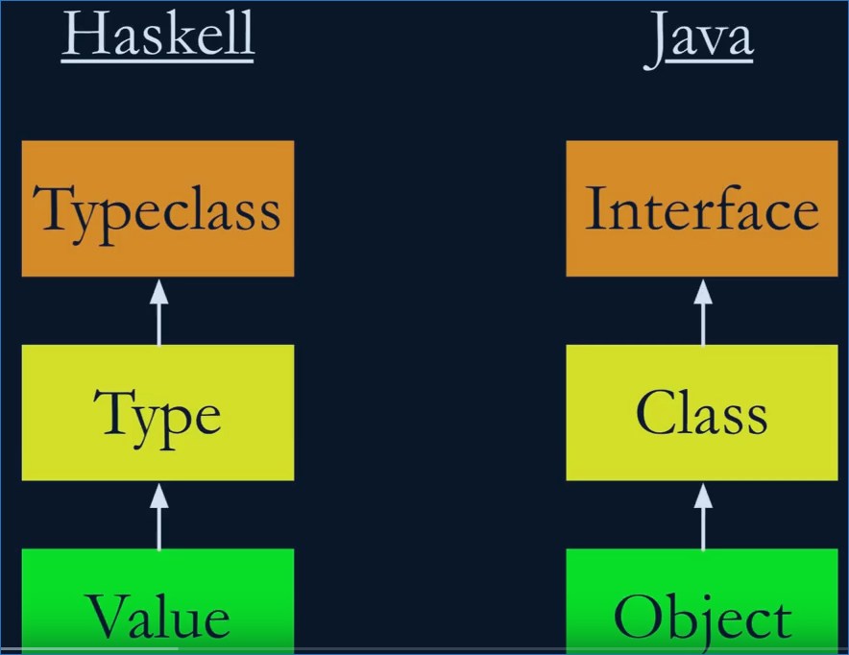
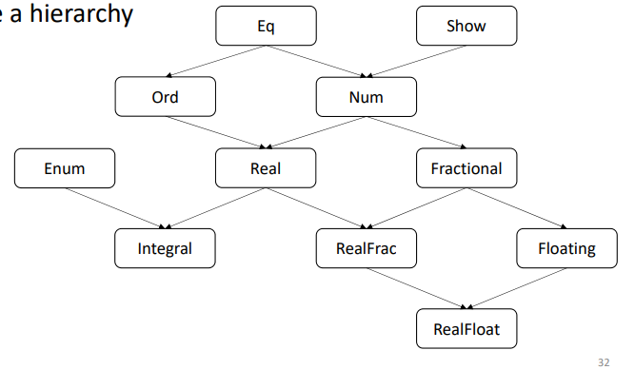
---

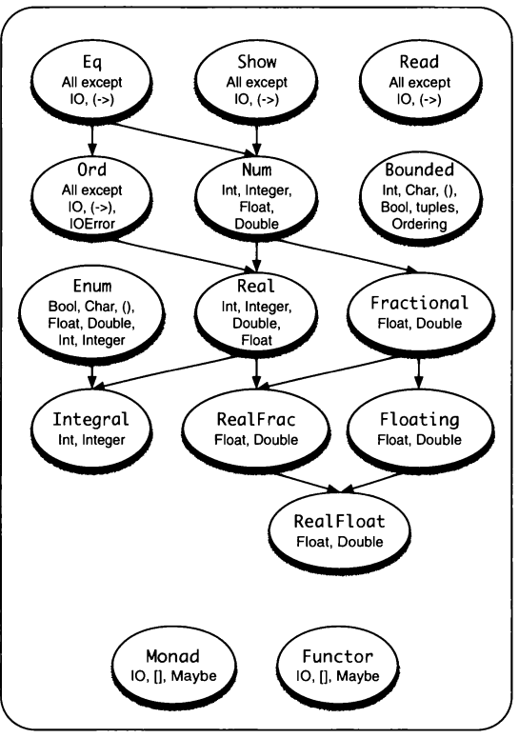

c `elem` ['A'..'Z']
`mod`, `rem` ; length
if True then --- else
succ, pred

sortBy, foldl, foldr ( with starting condition)
foldl1; foldr1 get first element as the starting
head, tail, init, last
zip, unzip, zipWith, words, unwords

Ordering (GT, LT or EQ )

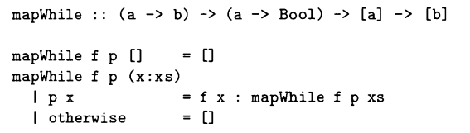

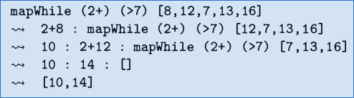

Class- Classtype
class HasLength a where
len :: a -> Int
instance HasLength [a] where
len x = length x

instance HasLength (a, b) where
len _ = 2

instance HasLength (a, b, c) where
len _ = 3

class (HasLength a) => CanBeEmpty a where -- CanBeEmpty is child from HasLength
isEmpty :: a -> Bool

instance CanBeEmpty [a] where
isEmpty [] = True
isEmpty _ = False

instance CanBeEmpty (a, b) where
isEmpty _ = False

instance CanBeEmpty (a, b, c) where
isEmpty _ = False

status :: CanBeEmpty a => a -> String
status x
| isEmpty x = "Empty"
| otherwise = "Contains " ++ (show (len x)) ++ " elements."

class Eq a where
(==) :: a → a→ Bool
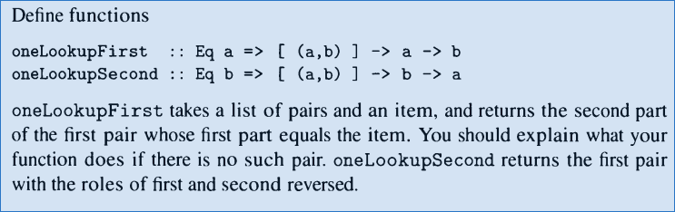

data Shape = Circle Float |
Rectangle Float Float |
Triangle Float Float Float deriving Show

area :: Shape -> Float
area (Circle r) = pi * r * r
area (Rectangle w h) = w * h
area (Triangle a b c) = sqrt(p * (p - a) * (p - b) * (p - c))
where p = (a + b + c) / 2

instance Eq Shape where
s1 == s2 = abs((area s1) - (area s2)) < 0.001
-- s1 == s2 = (area s1) == (area s2) -- this is because floating number

instance Show Shape where
show (Circle _) = "Circle"
show (Rectangle w h)
| w == h = "Square"
| otherwise = "Rectangle"
show (Triangle a b c)
| a == b && b == c = "equilateral triangle"
| a /= b && b /= c && a /= c = ""
| otherwise = "triangle"

data BinaryTree = NilT | Node Int BinaryTree BinaryTree deriving Show

height :: BinaryTree -> Int
height NilT = 0
height (Node _ left right) = 1 + max (height left) (height right)

inTree :: BinaryTree -> Int -> Bool
inTree NilT _ = False
inTree (Node x left right) target
| x == target = True
| otherwise = inTree left target || inTree right target

addNode :: BinaryTree -> Int -> BinaryTree
addNode NilT n = Node n NilT NilT
addNode (Node x left right) n
| n <= x = Node x (addNode left n) right
| otherwise = Node x left (addNode right n)

listToSearchTree :: [Int] -> BinaryTree -> BinaryTree
listToSearchTree [] t = t
listToSearchTree (x : xs) t = listToSearchTree xs (addNode t x)

list2tree :: [Int] -> BinaryTree -> BinaryTree
list2tree values t = foldl addNode t values

treeMap :: (Int -> Int) -> BinaryTree -> BinaryTree
treeMap _ NilT = NilT
treeMap f (Node x left right) = Node (f x) (treeMap f left) (treeMap f right)

data BST a = BSTNil | BSTNode a (BST a) (BST a)

bstAddNode :: (Ord a) => BST a -> a -> BST a
bstAddNode BSTNil n = BSTNode n BSTNil BSTNil
bstAddNode (BSTNode x left right) n
| n <= x = BSTNode x (bstAddNode left n) right
| otherwise = BSTNode x left (bstAddNode right n)

inOrder :: (Show a) => BST a -> String
inOrder BSTNil = ""
inOrder (BSTNode x left right) = (inOrder left) ++ show x ++ (inOrder right)

data BinaryTree = NilT | Node Int BinaryTree BinaryTree deriving Show

height :: BinaryTree -> Int
height NilT = 0
height (Node _ left right) = 1 + max (height left) (height right)

inTree :: BinaryTree -> Int -> Bool
inTree NilT _ = False
inTree (Node x left right) target
| x == target = True
| otherwise = inTree left target || inTree right target

addNode :: BinaryTree -> Int -> BinaryTree
addNode NilT n = Node n NilT NilT
addNode (Node x left right) n
| n <= x = Node x (addNode left n) right
| otherwise = Node x left (addNode right n)

listToSearchTree :: [Int] -> BinaryTree -> BinaryTree
listToSearchTree [] t = t
listToSearchTree (x : xs) t = listToSearchTree xs (addNode t x)

list2tree :: [Int] -> BinaryTree -> BinaryTree
list2tree values t = foldl addNode t values

treeMap :: (Int -> Int) -> BinaryTree -> BinaryTree
treeMap _ NilT = NilT
treeMap f (Node x left right) = Node (f x) (treeMap f left) (treeMap f right)

data (Ord a) => BST a = BSTNil | BSTNode a (BST a) (BST a)

bstAddNode :: (Ord a) => BST a -> a -> BST a
bstAddNode BSTNil n = BSTNode n BSTNil BSTNil
bstAddNode (BSTNode x left right) n
| n <= x = BSTNode x (bstAddNode left n) right
| otherwise = BSTNode x left (bstAddNode right n)

inOrder :: (Ord a, Show a) => BST a -> String
inOrder BSTNil = ""
inOrder (BSTNode x left right) = (inOrder left) ++ show x ++ (inOrder right)

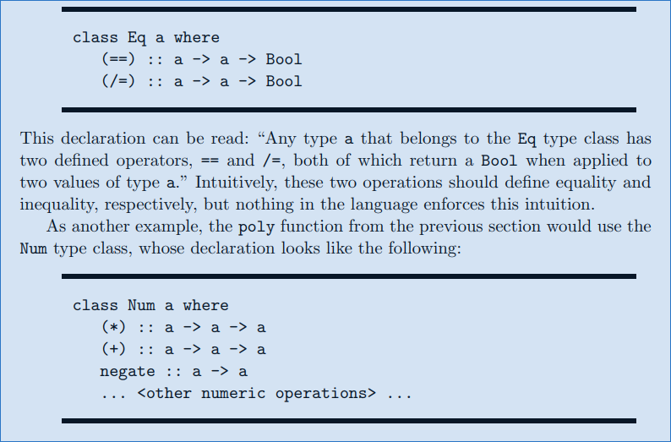
http://cmsc-16100.cs.uchicago.edu/2016/Lectures/07-type-classes.php

http://www.cs.tufts.edu/comp/150PLD/Notes/TypeClasses.pdf
http://andrew.gibiansky.com/blog/haskell/haskell-typeclasses/

